**PHYSICS**

**UNIT 3**

**2021**



**MARKING GUIDE**

**Name ____________________________________________________**

**Teacher ____________________________________________________**

**Time allowed for this paper**

Reading time before commencing work: ten minutes

Working time: three hours

**Materials required/recommended for this paper**

***To be provides by the supervisor***

This Question/Answer booklet

Formulae and Data booklet

***To be provided by the candidate***

Standard items: pens (blue/black preferred), pencils (including coloured), sharpener,

correction fluid, eraser, ruler, highlighters.

Special items: up to three non-programmable calculators approved for use in the WACE examinations, drawing templates, drawing compass and a protractor.

**Important note to candidates**

No other items may be taken into the examination room. It is **your** responsibility to ensure that you do not have any unauthorised material. If you have any unauthorised material with you, hand it to the supervisor **before** reading any further.

**Question 1 (4 marks)**

|  |  |
| --- | --- |
| **Description** | **Marks** |
| Accepted F =mv2/r for explanation | 1 |
| The mass of the star (m1) has not changed, | 1 |
| and the distance to the planet (r) has not changed, (Mark not deducted if this omitted and all else correct) | 1 |
| therefore centripetal acceleration of the planet will remain the same | 1 |
| **Total** | 4 |

**Question 2 (5 marks)**

|  |  |
| --- | --- |
| **Description** | **Marks** |
|  | 1 |
|  | 1-2 |
|  | 1 |
| Unknown moon (from table) is Proteus | 1 |
| **Total** | 5 |

**Question 3 (4 marks)**

|  |  |
| --- | --- |
| **Description** | **Mark** |
| Ek at P =Ekstart - Ep gained  **OR** | 1 |
|  | 1 |
| = 154 - 47 | 1 |
| = 1.07 x 102 J | 1 |
| **Total** | 4 |

Alternative methods: ½ mv2 + mg(15) = Ek at P + mg(19)

Or: Find v at P, using v2 = u2 + 2as (Or even harder: s= ut +½at2 and v = u +at) subst into

Ek = ½ mv2

**Question 4 (6 marks)**

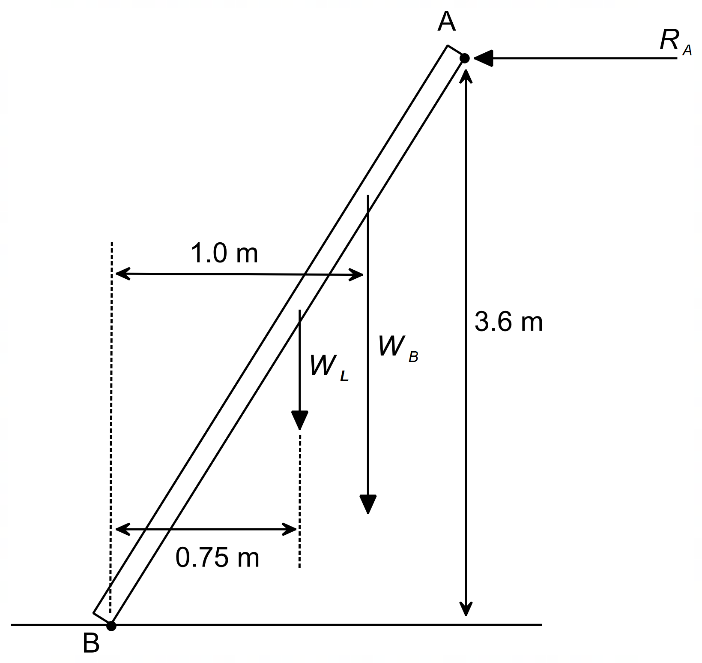

**Many did this the hard way.**

**Very easy to mix up sin and cos.**

**Cos ϴ = 1.5/3.9. ϴ = 67.4O**

**F. 3.9 sin 67.4 = 80 . 9.8 . 2/3.3.9 cos 67.4**

**+ 12 . 9.8 . 3.9/2 cos 67.4**

1. i) Calculate the reaction force of the wall on the ladder

|  |  |
| --- | --- |
| **Description** | **Marks** |
|  | 1 |
| Summing torques about point B | 1 |
|  | 1 |
| **Total** | 3 |

ii) Is this situation safe when the bricklayer is in the position described?

|  |  |
| --- | --- |
| Since the reaction force is less than 300 N, the situation is safe. | 1 |
| **Total** | 1 |

1. The bricklayer now moves to a position three-quarters up the length of the ladder. Explain how this makes the situation less safe.

|  |  |
| --- | --- |
| **Description** | **Marks** |
| Moving 75% up ladder increases the CW torque from *WB* about point B, thus also increasing the CCW torque required. (0 if this missed) | 1 |
| Thus, reaction force *RA* will increase closer to 300 N, causing the situation to be less safe. | 1 |
| **Total** | 2 |

**Question 5 (4 marks)**

1. 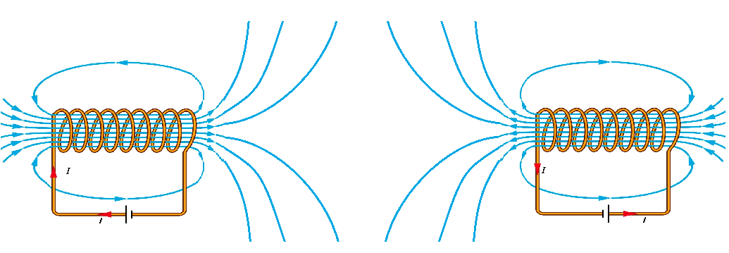

|  |  |
| --- | --- |
| **Description** | **Marks** |
| Correct shape 0 marks if no lines inside solenoids | 1 |
| Correct direction | 1 |
| **Total** | 2 |



|  |  |
| --- | --- |
| **Description** | **Marks** |
| The left solenoid produces a North pole at its end facing the right solenoid, while the right solenoid produces a North pole at its end facing the left solenoid | 1 |
| The two solenoids repel, so the left solenoid feels a force pushing it to the left. | 1 |
| **Total** | 2 |

**Question 6 (6 marks)**

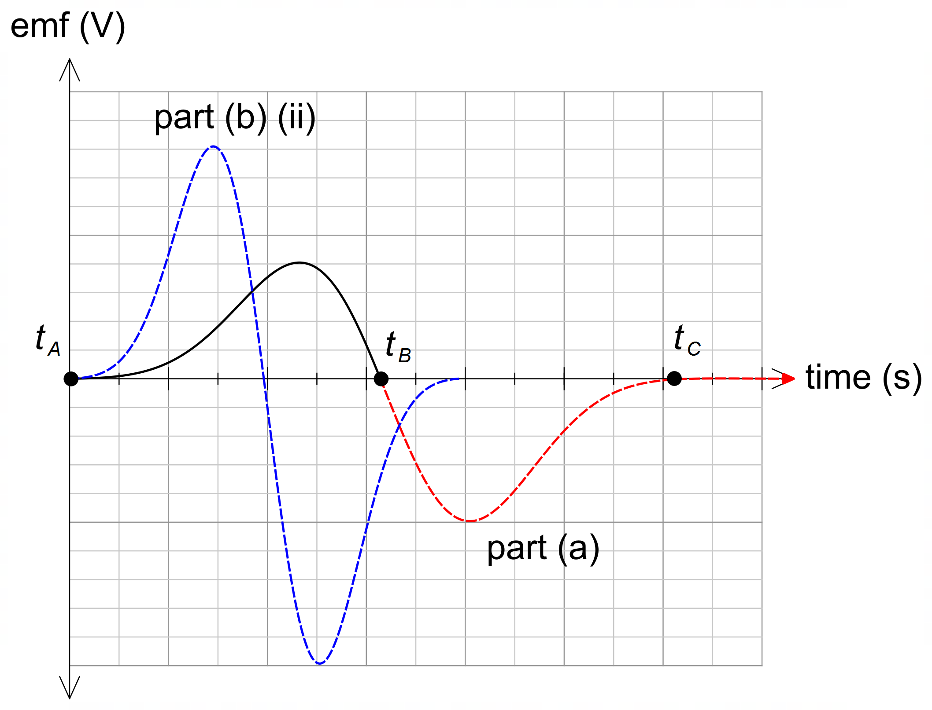

1. Complete the plot of the induced emf in the coil for the period the magnet moves between B and C. This will require you to mark and label *t C* on the graph. Ignore any effects of the Earth’s magnetic field.

|  |  |
| --- | --- |
| **Description** | **Marks** |
| Larger maximum voltage for second half between B and C compared to between A and B. | 1 |
| Time between B and C slightly shorter (due to increased velocity) than between A and B. | 1 |
| **Total** | 2 |

1. The following changes are then made to this experiment:
   1. This equipment is now placed in an external vertical magnetic field. The external magnetic field is twice the strength of the magnetic field of the magnet. With reference to relevant Physics concepts, explain the effect on the output emf.

|  |  |
| --- | --- |
| **Description** | **Marks** |
| The induced emf is proportional to the rate of change of flux due to the movement of the magnet through the coil (Faraday’s law)  EMF produced only when flux changing: OK for 1 mark | 1 |
| Since the field due to the external magnetic field is constant, the output emf will be unaffected. | 1 |
| **Total** | 2 |

1. This experiment is now performed on a planet where the acceleration due to gravity is 19.6 m s–2. Draw the resulting emf output on the graph above for this location. (2 marks)

|  |  |
| --- | --- |
| **Description** | **Marks** |
| On graph in blue – twice magnitude, second half larger than first half | 1 |
| On graph in blue – reduced time in the coil | 1 |
| **Total** | 2 |

**Question 7 (3 marks)**

|  |  |
| --- | --- |
| **Description** | **Marks** |
| Polarity of both charges is positive | 1 |
|  | 1 |
| Vector drawn horizontal to the left, equal in size to *FB* | 1 |
| **Total** | 3 |

**Question 8 (6 marks)**

|  |  |
| --- | --- |
| **Description** | **Marks** |
|  | 1 |
|  | 1 |
|  | 1 |
| (1 mark)  (1 for r = 0.04 cm) | 1 – 2 |
|  | 1 |
| **Total** | 6 |

**Question 9 (4 marks)**

|  |  |
| --- | --- |
| **Description** | **Marks** |
| If mg is missing 2 marks only | 1 |
|  | 1-2 |
|  | 1 |
| **Total** | 4 |

**Question 10 (4 marks)**

|  |  |
| --- | --- |
| **Description** | **Marks** |
| PE lost = KE gained | 1 |
| mgh = ½ mv2  ⇒ v2 = 2gh = 2gr | 1 |
| As ball moves through lowest point in swing,  tension FT = Fc + FW = mv2/r + mg | 1 |
| m(2gr)/r + mg = 2mg + mg = 3mg = 3 x FW | 1 |
| **Total** | 4 |

**Question 11 (4 marks)**

|  |  |
| --- | --- |
| **Description** | **Marks** |
| Σ F = ma  ⇒ ma = FT - Fslope -FFr | 1 |
| FT = 163 x 1.00 + 163 x 9.8 x sin (11) + 60.0 | 1 – 2 |
| FT = 528 N | 1 |
| **1 mark if Fslope is calculated correctly Total** | 4 |

**Question 12 (4 marks)**

.

|  |  |
| --- | --- |
| **Description** | **Marks** |
| The gymnast is still in equilibrium. | 1 |
| Therefore their weight is cancelled by the  two vertical components of the tension.  i.e.  ⇒ | 1 |
| As the arms are outstretched,  the angle increases, cos θ gets smaller, | 1 |
| the tension must increase | 1 |
| **No marks for torque Total** | 4 |

**Question 13 (12 marks)**

(a)

|  |  |
| --- | --- |
| **Description** | **Marks** |
| A-B-C-D | 1 |
| **Total** | 1 |

(b)

|  |  |
| --- | --- |
| **Description** | **Marks** |
| F = N I l B  = 15 x 1.50 x 0.1 x 0.550 | 1 |
| = 1.24 N | 1 |
| **Total** | 2 |

c)

|  |  |
| --- | --- |
| **Description** | **Marks** |
| Ʈ = 2 r F  = 2 x 0.05 x 1.24 | 1 |
| = 0.124 Nm | 1 |
| **Total** | 2 |

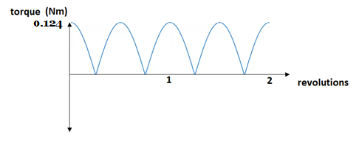(d)

|  |  |
| --- | --- |
| **Description** | **Marks** |
| Correct shape | 1 |
| Correctly labelled axis | 1 |
| **Total** | 2 |

e)

|  |  |
| --- | --- |
| **Description** | **Marks** |
| Increase the current in the coil  Increase the magnetic field  Replace coil with one of a larger cross-sectional area  More turns on the coil | Any three  1 mark each |
| **Total** | 3 |

(f)

|  |  |
| --- | --- |
| **Description** | **Marks** |
| Changes the direction of the current every 180 o | 1 |
| So that the coil always rotates in the same direction | 1 |
| **Total** | 2 |

**Question 14 (18 marks)**

1. Calculate the vertical and horizontal components of the initial speed of the water as it exits the hose. **(2 marks)**

|  |  |
| --- | --- |
| **Description** | **Marks** |
|  | **1** |
|  | **1** |
| **Total** | **2** |

1. Determine the height above the ground the water is being released from if the water travels a horizontal distance of 16.0 m to the far edge of the lawn.

|  |  |
| --- | --- |
| **Description** | **Marks** |
|  | **1 – 2** |
|  | **1 – 2** |
| **Total** | **4** |

1. **Determine the maximum height the water reaches above the end of the hose.**

|  |  |
| --- | --- |
| **Description** | **Marks** |
|  | **1** |
|  | **1** |
|  | **1** |
| **Total** | **3** |

1. Using the information in the question, draw a velocity-time graph and an acceleration-time graph for the water droplet for the period between leaving the hose and hitting the grass. Assume that upwards is a positive frame of reference. Indicate and label all key features of each graph. Ignore the effects of air resistance for this question.

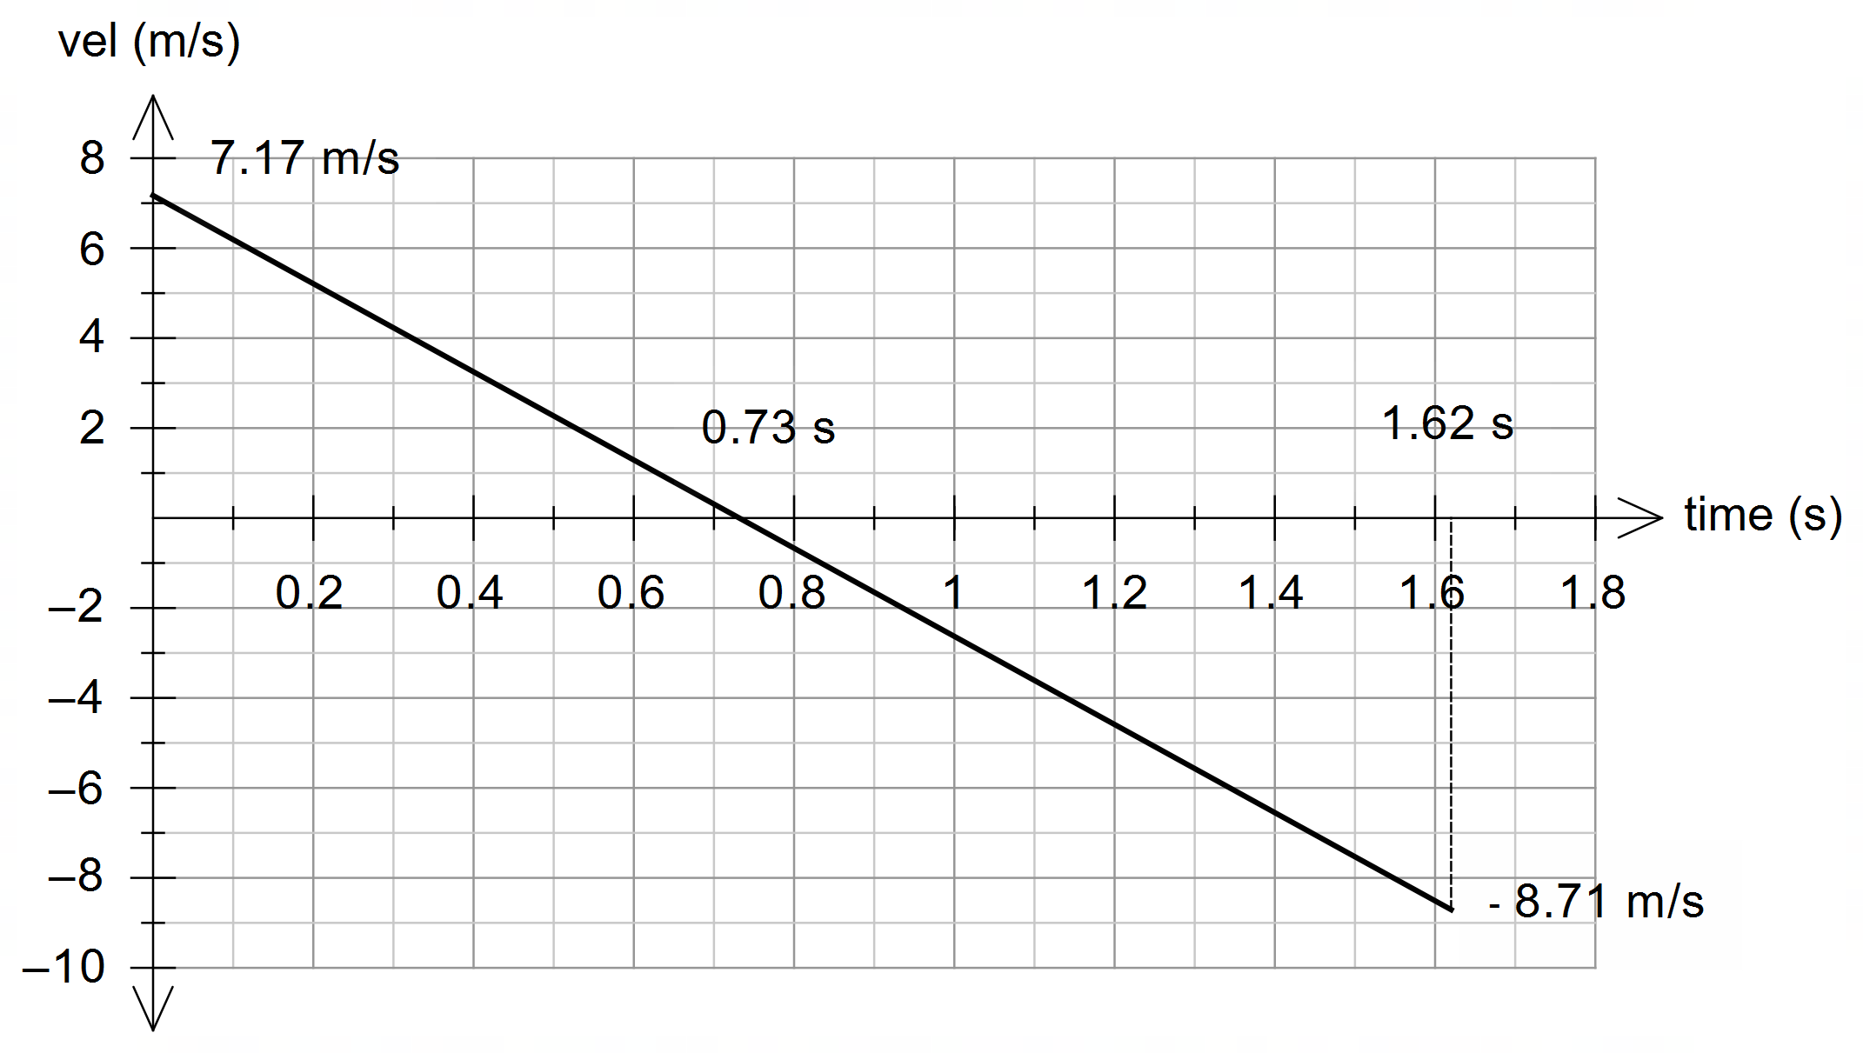

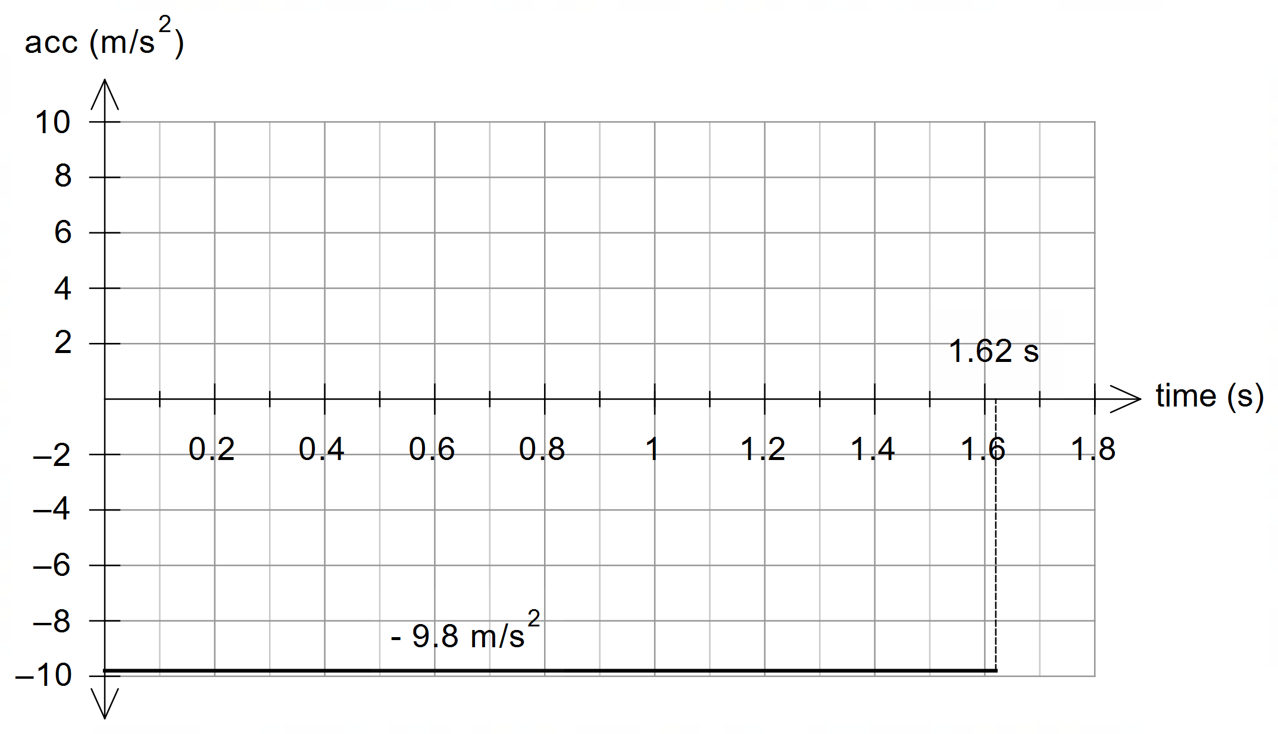

|  |  |
| --- | --- |
| **Description** | **Marks** |
| Correct initial velocity on graph (~7.2 m/s) | 1 |
| Indicates correct final time on graph (1.62 s) | 1 |
| Velocity-time graph is linear with gradient of –9.8 m/s2 | 1 |
| Acceleration-time graph is linear with a gradient of 0 | 1 |
| Acceleration-time graph is constant at –9.8 m/s2 | 1 |
| Key features are labelled on graph | 1 |
| **Total** | 6 |

1. State three (3) ways in which the motion of a water droplet exiting the hose is affected by drag force due to air resistance.

|  |  |
| --- | --- |
| **Description** | **Marks** |
| **Three of the following:** |  |
| Reduced range | 1 |
| Reduced maximum height | 1 |
| Decreased time of flight | 1 |
| Asymmetrical nature of motion (i.e. – no longer a perfectly parabolic path) | 1 |
| The horizontal velocity component decreases – no longer constant – hence reduced range | 1 |
| The vertical velocity component decreases at a greater rate – hence reduced height | 1 |
| The vertical velocity component downwards still increases but at a slower rate | 1 |
| **Total** | 3 |

**Question 15 (7 marks)**

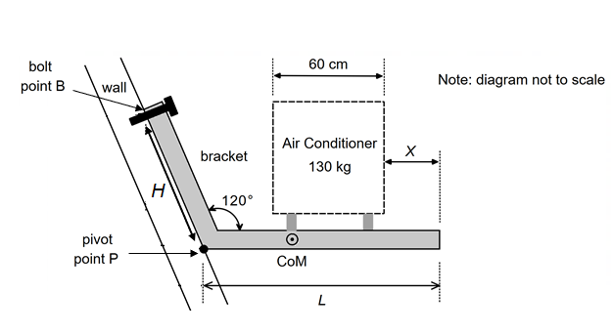

|  |  |
| --- | --- |
| **Description** | **Marks** |
|  | 1 |
|  | 1 |
|  | 1 – 2 |
|  | 1 – 2 |
|  | 1 |
| **Total** | 7 |

**Question 16 (15 marks)**

1. Calculate the orbital speed that the spacecraft should have at the location indicated by X for it to maintain a stable orbit at an altitude of 4000 km.

|  |  |
| --- | --- |
| **Description** | **Marks** |
|  | 1 |
| Uses distance of 4000 km + 3390 km = 7390 km | 1 |
|  | 1 |
|  | 1 |
| **Total** | 4 |

1. Using your answer to part (a), given data and relevant physics concepts, explain why the Mars2021 will continue to descend from an altitude of 4000 km.

|  |  |
| --- | --- |
| **Description** | **Marks** |
|  | 1 |
| A satellite travelling slower than the stable orbital speed will fall to a lower orbit. | 1 |
| The actual speed of the spacecraft (1.95 km/s) is slower than the stable orbital speed (2.40 km/s), thus it will “fall”. | 1 |
| **Total** | 3 |

1. Use the area under the graph to estimate the change in potential energy of the spacecraft as it descends from an altitude of 4000 km to an altitude of 500 km. Show working.

|  |  |
| --- | --- |
| **Description** | **Marks** |
|  | 1 |
|  | 1 |
|  | 1 |
| 2 sig figs | 1 |
| **Total** | 4 |

1. Using your answer to part (c), determine the final speed of the spacecraft as it reaches an altitude of 500 km altitude. [Note: if you did not get an answer to part (c) use 5 GJ for the change in potential energy]

|  |  |
| --- | --- |
| **Description** | **Marks** |
|  | 1 |
|  | 1 |
|  | 1 |
|  | 1 |
| **Total** | 4 |

**Question 17 (14 marks)**

1. On the diagram above, draw and label the electric field *E* in the region between the two plates. Draw at least four (4) field lines.

|  |  |
| --- | --- |
| **Description** | **Marks** |
| Electric field lines directed from bottom plate to top plate | 1 |
| Electric field lines should be uniform (4 or more lines shown) | 1 |
| **Total** | 2 |

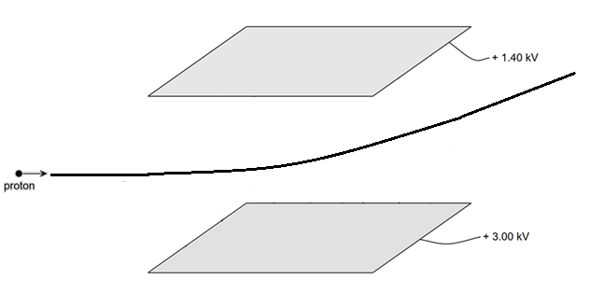

1. Show on the above diagram the path of the proton, as it travels from region A through to the end of region C. (3 marks)

|  |  |
| --- | --- |
| **Description** | **Marks** |
| Straight line motion before entering field | 1 |
| Curves upwards in field | 1 |
| Continues in a straight line at a tangent to the curve | 1 |
| **Total** | 3 |

1. Determine the magnitude of the force due to the electric field acting on the proton while it is between the parallel plates. (3 marks)

|  |  |
| --- | --- |
| **Description** | **Marks** |
|  | 1-2 |
| = 5.12 x 10-19 N | 1 |
| **Total** | 3 |

1. What is the final velocity of the proton when it exits the electric field? (6 marks)

|  |  |
| --- | --- |
| **Description** | **Marks** |
| t =  =  = 1.85 x 10-5 s | 1 |
| a =  =  = 3.07 x 108 ms-2 | 1 |
| v = u + at  = 0 + x 3.07 x 108 x 1.85 x 10-5  = 5.68 x 103 ms-1 | 1 |
| vR = √((3.25 x 104)2 + (5.68 x 103)2)  = 3.30 x 104 ms-1 | 1 |
| Ɵ = tan-1 (5.68 x 103 / 3.25 x 104)  = 9.91o | 1 |
| Final velocity = 3.30 x 104 ms-1 at 9.91o above the horizontal | 1 |
| **Total** | 6 |

**Question 18 (12 marks)**

1. As the centre of the coil moves from point A to B, it experiences an average induced EMF equal to 2.50 × 10–6 V. Determine the speed of the coil.

|  |  |
| --- | --- |
| **Description** | **Marks** |
|  | 1 |
|  | 1 |
|  | 1 |
|  | 1 |
|  | 1 |
|  | 1 |
| **Total** | 6 |

1. Will the induced EMF in the coil be greater at point A or point B? Justify your choice. No calculations are needed.

|  |  |
| --- | --- |
| **Description** | **Marks** |
|  | 1 |
|  | 1 |
|  | 1 |
| **Total** | 3 |

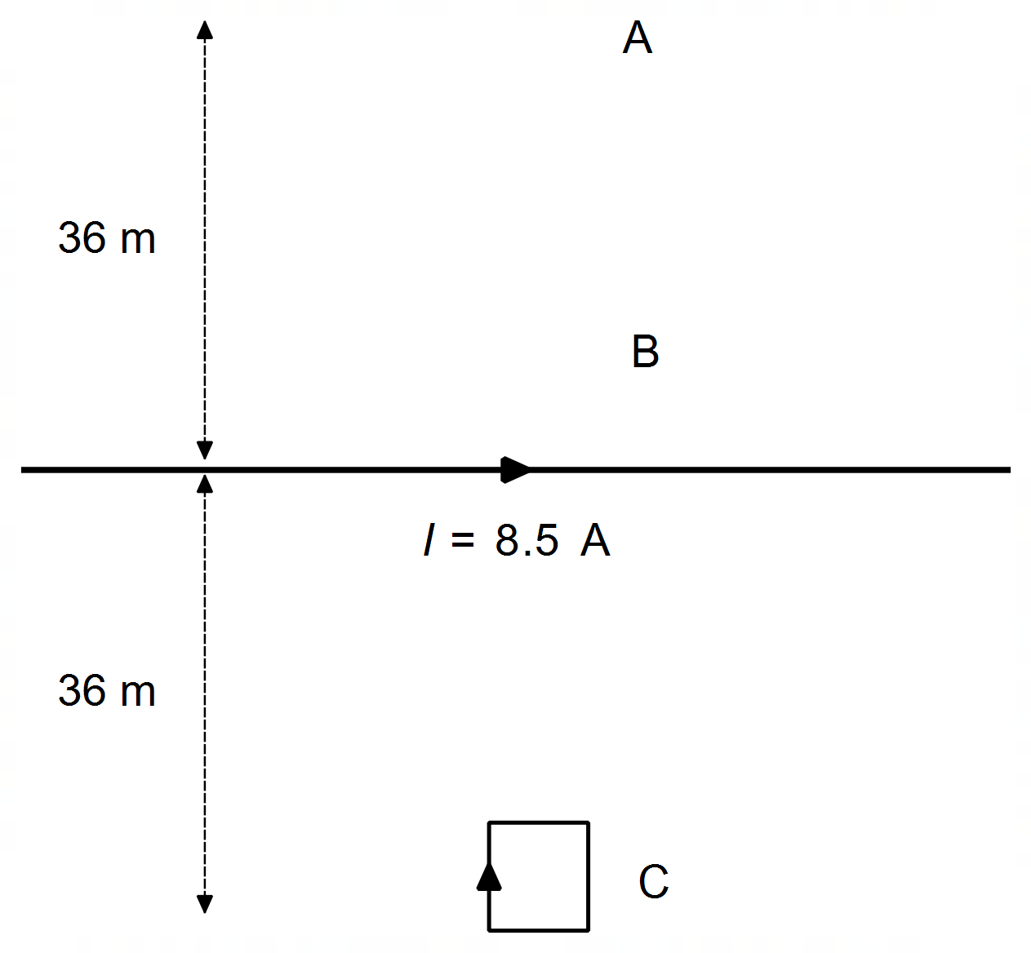

1. On the diagram above, draw the coil at point C and indicate the direction of the induced current in the coil at this location. With reference to a relevant physics concept, explain the reason you drew the current in the direction you did.

|  |  |
| --- | --- |
| **Description** | **Marks** |
|  | 1 |
|  | 1 |
|  | 1 |
| **Total** | 3 |

**Question 19 (12 marks)**

(a) **(2 marks)**

**-1 mark for incorrect/extra forces**

**FT must be longer that Fg. Force lines must originate from the centre of the body. Fg must be directly vertical**

**Fg**

**FT**

(b)

|  |  |
| --- | --- |
| **Description** | **Marks** |
| For the net force to be exactly horizontal the vertical weight force needs to be balanced by another force – in this case the vertical component of the tension.  Do not mention centrifugal force or inertial force | 1 |
| The tension force obviously also needs to provide a horizontal force, in this case, the centripetal force, causing circular motion. | 1 |
| Since both components are non-zero, the string will always be at some angle below horizontal | 1 |
| **Total** | 3 |

**Alternate Solution**

|  |  |
| --- | --- |
| **Description** | **Marks** |
| For perfect horizontal motion, there would be no vertical component of the tension | 1 |
| However, there must be a vertical weight force, which is therefore unbalanced | 1 |
| So perfect horizontal motion is not possible, and the string will always be dipped | 1 |
| **Total** | 3 |

.

c)

|  |  |
| --- | --- |
| **Description** | **Marks** |
|  | 1 |
|  | 2 |
|  | 1 |
| **Total** | 4 |

(d)

|  |  |
| --- | --- |
| **Description** | **Marks** |
| F = mv2 Therefore, if the velocity increases, centripetal force will increase.  r | 2 |
| Thus, the horizontal component of the tension also increases | 1 |
|  |  |
| **Total** | 3 |

**Question 20 (18 marks)**

1. Briefly explain why a “crown elevation” road profile is not suitable for the design of a road surface where cars are travelling around a corner.

|  |  |
| --- | --- |
| **Description** | **Marks** |
|  | 1 |
|  | 1 |
| **Total** | 2 |

1. Determine the angle  for a “super elevated” road with a slope of 2.5%.

|  |  |
| --- | --- |
| **Description** | **Marks** |
|  | 1 |
| **Total** | 1 |

1. Without using equation 2, show that the maximum speed of a car navigating a corner on flat ground, with friction, is given by the expression:

|  |  |
| --- | --- |
| **Description** | **Marks** |
|  | 1 |
|  | 1 |
|  | 1 |
| **Total** | 3 |

1. Calculate the three (3) possible maximum speeds that a car could navigate a bend on a road with a radius 46 m on a normal, dry day under the three following conditions (note: if you could not determine  for part (b) then use  = 2.0°):

|  |  |
| --- | --- |
| **Description** | **Marks** |
| From text | 1 |
|  | 1 |
|  | 1 |
|  | 1 |
| **Total** | 4 |

1. A sports car is navigating a racecourse with seven bends which are all on flat ground. The driver of the sports car drives as fast as possible without their car skidding around each corner. For each bend, the radius; the maximum velocity; and the square root of radius are listed in the table below.

|  |  |  |  |
| --- | --- | --- | --- |
| **Corner** | **Radius *r* (m)** | **Velocity *v* (m s-1)** |  |
| 1 | 19.1 | 12.5 | 4.37 |
| 2 | 8.30 | 8.90 | 2.88 |
| 3 | 41.5 | 18.0 | 6.44 |
| 4 | 68.0 | 23.4 | 8.25 |
| 5 | 31.5 | 16.7 | 5.61 |
| 6 | 114 | 31.0 | 10.7 |
| 7 | 54.0 | 20.7 | 7.35 |

1. Use the information in the table to graph the velocity v versus the square root of radius on the set of axes provided below. Draw a line of best fit.

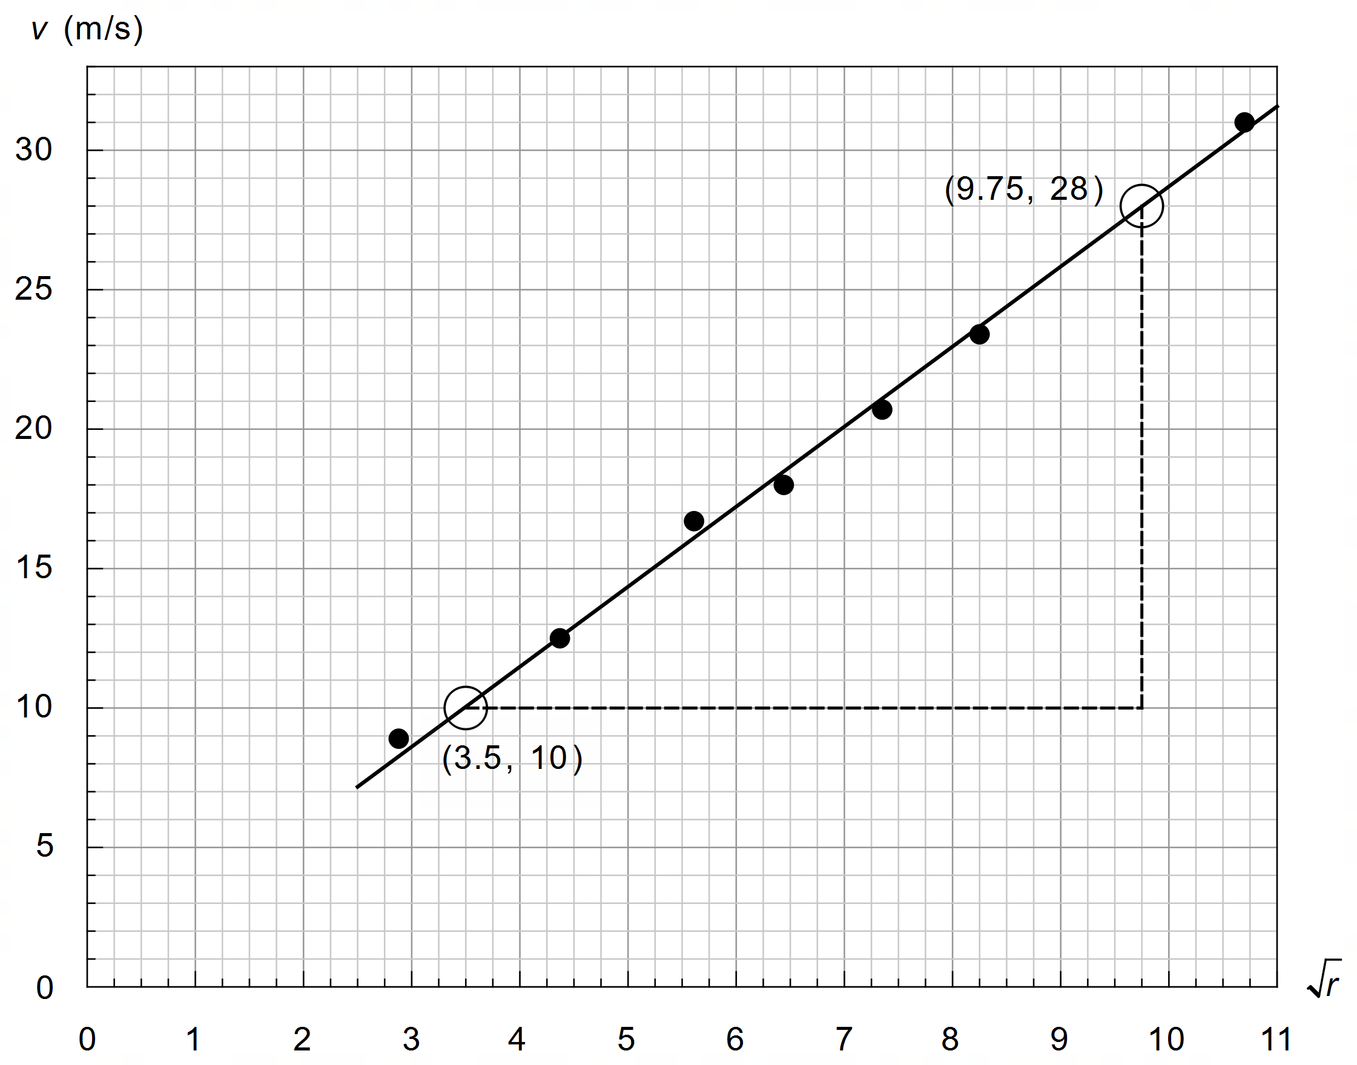

|  |  |
| --- | --- |
| **Description** | **Marks** |
|  | 1 |
|  | 1 |
|  | 1 |
| **Total** | 3 |

1. Determine the gradient for your line of best fit and use it to estimate a value for the coefficient of friction µ on the racecourse. Indicate clearly how you used your graph to calculate the gradient. Give your answer to an appropriate number of significant figures. Based on your result, explain the likely conditions of the road that day.

|  |  |
| --- | --- |
| **Description** | **Marks** |
| Construction lines (triangle) should be large and not include table points | 1 |
| Accept between 2.7 and 3.0 | 1 |
|  | 1 |
|  | 1 |
|  | 1 |
| **Total** | 5 |

**Question 21 (18 marks)**

**Galvanometers**

1. On Figure 4 indicate the direction of the torque provided by the coil.

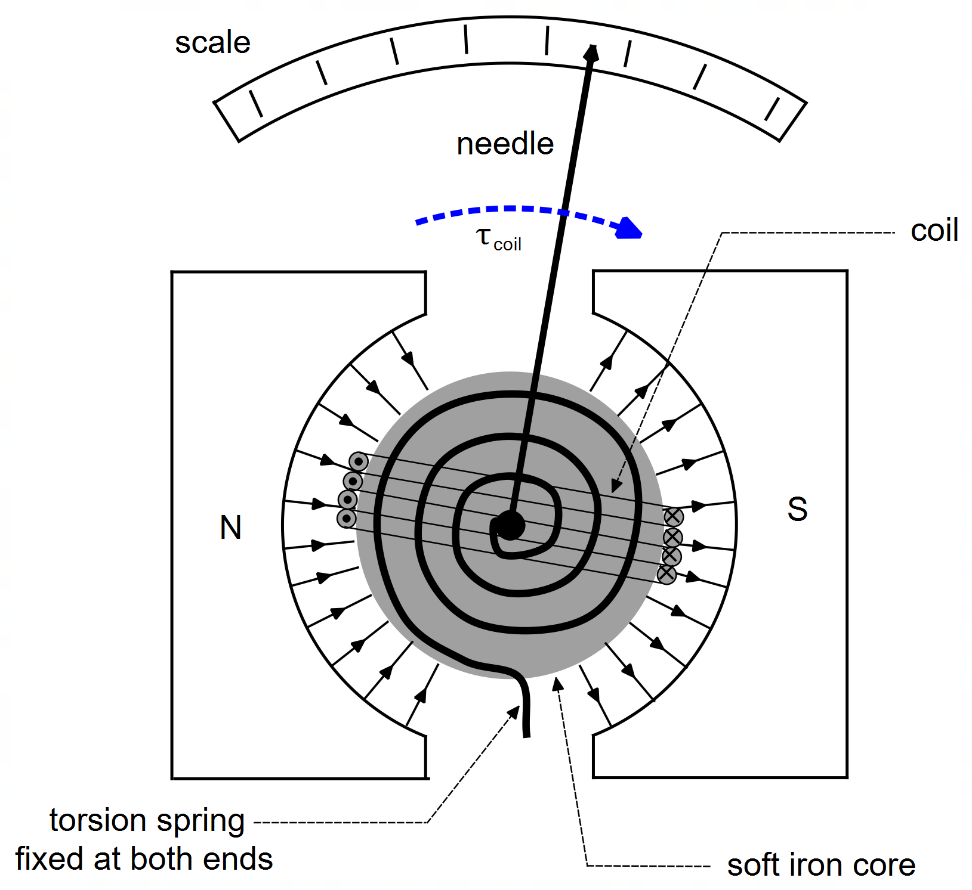

|  |  |
| --- | --- |
| **Description** | **Marks** |
| Torque acting in a clockwise direction on diagram. | 1 |
| **Total** | 1 |

1. Explain the importance of the circular shape of the permanent magnets.

|  |  |
| --- | --- |
| **Description** | **Marks** |
|  | 1 |
|  | 1 |
|  | 1 |
| **Total** | 3 |

1. State two (2) likely sources of an inaccurate reading when using a galvanometer.

|  |  |
| --- | --- |
| **Description** | **Marks** |
| Stiffness of the spring is not constant | 1 |
| The magnetic field between the poles and core is not uniform (or not circular in shape) | 1 |
| **Total** | 2 |

1. With reference to relevant physics concepts, explain how eddy currents in the metal core help the needle of DC galvanometer to quickly come to a reading without vibrating back and forth?

|  |  |
| --- | --- |
| **Description** | **Marks** |
| A change in flux in the metal core produces eddy currents | 1 |
|  | 1 |
| Reducing the torque on the needle | 1 |
| Stopping the needle quickly and therefore reducing any vibration | 1 |
| **Total** | 4 |

1. Ideally, the angle of deviation of the needle of a galvanometer should be directly proportional to the current in the coil. In other words: Use equation 3 to determine an expression for the constant *C*.

|  |  |
| --- | --- |
| **Description** | **Marks** |
|  | 1 |
|  | 1 |
| **Total** | 2 |

1. A certain galvanometer has a rectangular 3.0 cm by 4.0 cm coil wrapped around a soft iron metal core. The core is attached to a torsion spring with stiffness *k* = 3.50 × 10-3 Nm per °. The coil and core arrangement sit in the region between two circular magnetic poles with a magnetic field strength of 550 mT. The coil has 38 turns of wire.
2. Determine the angle the needle deviates when a known current of 1.76 A passes through the coil.

|  |  |
| --- | --- |
| **Description** | **Marks** |
|  | 1 |
|  | 1 |
|  | 1 |
| **Total** | 3 |

1. Unfortunately, the scale on the galvanometer is no longer legible. An unknown current is passed through the device such that the needle deviates exactly three divisions, through an angle of 21.5°. How much current (A) is represented by each division on the scale?

|  |  |
| --- | --- |
| **Description** | **Marks** |
|  | 1 |
|  | 1 |
|  | 1 |
| **Total** | 3 |

Alternatively:

|  |  |
| --- | --- |
| **Description** | **Marks** |
|  | 1 |
|  | 1 |
|  | 1 |
| **Total** | 3 |

**END OF EXAMINATION**